

217, Sheikh Rashid Building

P.O Box 56272, Dubai

United Arab Emirates

Tel: +971 4 2973236 / 04 2974007

Email: uae@verbat.com

PROJECT   
PROPOSAL

**Integrated Permit Issuance Online System**

|  |  |
| --- | --- |
| **Prepared for:**  **Ahmed Obaid Al Tunaiji** | **Submission Date:**  22 May 2017  **Proposal ID:** AD/BP/22052017/1343/1 |

___________________________________________________________________________________________________________________________________________  
Conﬁdentiality Notice: This Proposal is conﬁdential and contains proprietary information and intellectual property of Verbanet Technologies LLC. Neither this proposal nor any of the information contained herein may be reproduced or disclosed under any circumstances without the express written permission of Verbanet.

© 2017 by Verbanet Technologies LLC. All rights reserved. Confidential.

___________________________________________________________________________________________________________________________________________

Project Contacts

|  |  |
| --- | --- |
| Client Information | |
| Project Name | Integrated Permit Issuance Online System |
| Client Name | Sharjah Commerce and Tourism Development Authority |
| Client Address | Buheira Corniche Road - Sharjah - United Arab Emirates |
| Contact Person | Mr. Ahmed Obaid Al Tunaiji |
| Contact Person Email | Ahmed.ot@Sharjahtourism.ae |
| Contact Person Phone Number | 9 716 519 0961 |
| Verbat Information | |
| Contact Person | Joyce Daniel |
| Contact Person Phone Number | +971 42973236 |
| Contact Person E-Mail | [joyce.daniel@verbat.com](mailto:joyce.daniel@verbat.com) |
| Address | PO Box 56272, Dubai, United Arab Emirates |
| Physical Address | 217, Sheikh Rasheed Building, Hor Al Anz East |
| Project Information | |
| Proposed Technology/Methodology | AngularJS, NodeJS, ExpressJS, MongoDB |
| Anticipate Start Date | NA |
| Proposal Valid For | 30 Calendar days from the submission of the proposal |

**Table of Content**

1 Scope of Work 6

1.1 Key Platform Stakeholders / “Actors” 6

1.2 Proposed Solution Model 7

1.3 Solution Objective 8

1.3.1 New / Renew application for permits 8

1.3.2 Data Processing, Storage and Retrieval of applications 8

1.3.3 Payments 8

1.3.4 Reports 8

1.3.5 Permit issuance and (Re) Printing 9

1.3.6 Permit Cancellation 9

1.3.7 Inspection 9

1.3.8 Communication and Information Delivery 9

1.3.9 Guides 10

1.3.10 Languages 10

1.4 Advantages of Proposed Solution 11

1.5 Why Verbat 11

1.6 Key Differentiators 12

1.7 Technology & Services 13

2 Functional Specification 14

3 Functional Architecture 16

3.1 Application Level features 17

3.2 System Level Features 18

4 High Level Solution 20

4.1 High Level Architecture 20

4.2 Overall System Workflow (High Level) 22

4.3 System Workflow (High Level) 23

5 Nonfunctional Requirement (Others) 25

6 Assumptions 25

7 Out of Scope 26

8 Technology Solution 27

8.1 Proposed System Environment 27

8.2 Technical Configurations 28

8.2.1 Development Tools 28

8.2.2 Recommended Web Hosting Package 28

8.2.3 Browser Compatibility 28

8.2.4 Hardware Interface 28

9 Commercials 29

9.1 Web Application 29

9.2 Payment Terms 29

9.3 Mode of Payment 29

10 Delivery Management 30

10.1 Project Management 30

10.2 Roles and Responsibilities 30

10.3 Delivery Activity Summary 31

10.4 Project Implementation Plan 31

10.5 Deliverables 31

10.6 Estimated Delivery Time 32

10.7 Deployment Details (at Clients Behest) 33

10.8 Release Planning 33

10.9 Risk and Contingency Planning 33

11 Change Management 34

12 Miscellaneous 36

12.1 Acceptance Criteria 36

12.2 General Terms and Conditions 36

12.3 Assumptions and Dependencies 37

12.4 Source Code & Intellectual Property Rights 38

12.5 Maintenance & Support 38

12.6 Service Level Agreement 39

13 Our Clients 40

# Scope of Work

Sharjah Commerce and Tourism Development Authority (Hereafter referred to as the “Client”) has tendered an RFP to aid in the development of an integrated online application that facilitates issuance of license to operate 4x4 desert safari tourism vehicles in Sharjah. The proposed system shall minimize the time spend in managing permit applications as well as other transactions. To ensure the safety of tourist, the client would like to enforce the safety of safari vehicles along with the capability of the vehicle drivers. The system will aide in the issue of permits; an acknowledgement of the tour operators compliance with all conditions and laws related to environment, security & safety set forth by the tourism department (Client). An online system will facilitate faster processing of applications; notwithstanding applications for renewal, cancellations, vehicle inspections, ordering reprints or copies of permits.

The primary objectives of the application are

1. A multipurpose one stop gateway for permit processing including new permit applications, permit renewals, permit cancellations & expiry, vehicle inspections, fees and fine settlement.
2. Reduce permit processing and sticker printing time by issuing electronic permits and vehicle stickers with countermeasures to thwart duplication & forgeries
3. Real time tracking of the application process and vehicle inspection results
4. Consolidated information store for all activities related to permit processing
5. Automate verification of documents submitted by crosschecking with Muroor
6. Automate fine and fees computation along with integration of payment using credit cards and Tahseel
7. Management dashboard with access to various reports and analytics.
8. Smart workflows that identify the process and automatically assign to the individual in the chain of responsibility to act on the application

Verbat is pleased to submit the proposal and values it as a great opportunity to have a long term & mutually beneficial association with the client. Verbat has gone through the requirement and presents a proposal for the requested system.

## Key Platform Stakeholders / “Actors”

1. **Applicants:** Users from the general public who are trying to receive a new permit or trying to renew their permits
2. **Permit Holders:** Applicants who were successful in getting permits. They will have access to the portal to manage their personal information, make amendments or look up status of pending approvals.
3. **Application Processors (Counter):**  Verification of the documents provided as proof are validated by processors. They may defer the approval of the application to the TSD manager.
4. **TSD Manager:** Dispute resolution or cases where vehicles need to be inspected are deferred to the manager. Manager can issue new permits as well as assign cases to the vehicle inspectors
5. **Vehicle Inspectors:** Vehicle inspectors inspect vehicles based on an inspection checklist. Inspectors will log the results of the inspection along with evidence, in the application, which will be made available to the TSD manager.
6. **System:**  The system has intelligence built into it that can identify vehicles that need to be inspected soon, permits that are nearing expiration etc. The system will issue appropriate alerts, mails and SMS messages to the concerned. System can automatically disable access to accounts that expired or cancelled their application

## Proposed Solution Model

**Stand-Alone Fixed Bid**

Verbat will be following a stand–alone fixed bid solution delivery model wherein the required solution would be devised and a suitable pricing would be offered.

## Solution Objective

Verbat intends to build a one stop solution to manage and process permits for 4x4 safari vehicles used by tourist. The system shall automate the process thus reducing turnaround times and increasing efficiency. The system will provide tools for application processing, printing of permits & stickers, fee calculation & collection, and reporting. The salient features of the application to be developed are noted below

### New / Renew application for permits

* Online application with unique user name and password
* Attach documents to supplement the application
* Receipt of acknowledgement of the application via email
* Email notification of the application to TSD
* Application review by TSD with a checklist of the document requirements
* Notify results of the application to applicant; i.e. whether it was approved, rejected, need to fulfil additional requirements etc.

### Data Processing, Storage and Retrieval of applications

* File creation, storage and retrieval
* Application tracking
* Application Query management

### Payments

* Fees and fine computation
* Payment options by major credit cards or Tahseel
* E-receipt generation and printing

### Reports

* Report Creation
* Report Generation: On-Demand or periodic reports with option to specify the data range and time period
* Templated and printable reports in PDF format (SCTDA/TSD templates to be provided)
* Report access for finance & TSD based on entitlements

### Permit issuance and (Re) Printing

* Retrieval and review of application results for approval
* Identity verification
* Issue permit number and automatic cancellation of already issued permit numbers.
* (Re) Printing of permit sticker
* Acknowledgement receipts with applicants electronic or written signature

### Permit Cancellation

* Retrieve information on the applicant
* Generate reports on fines, fees, complaints etc.
* Review pane and checklist for cancellation assigned to TSD staff
* Cancellation results via notifications to applicant
* Automatic cancellation of permit number and access to the system after email notifications have been send to the applicant

### Inspection

* TSD manager publishes inspection schedule to TSD Inspector
* Inspector access to the system
* Inspection interface and checklist accessible to assigned TSD staff. E.g. permit validity, ability to scan barcodes etc.
* Inspection re-scheduling and notification
* ‘Inspection activity and inspection history reports
* Automatic computation of fines based on observation & inspection results
* Inspection tracking in real time
* Email notification of inspection results to TSD manager

### Communication and Information Delivery

* Automatic expiry notification emails to permit holders and TSD staff
* Complaints management

### Guides

* Onscreen guides to the logged in user regarding the application workflow
* System guides for application user (TSD , applicant & Permit holder)

### Languages

* English & Arabic

Detailed requirements will be covered in the section titled “Functional Specifications”

Verbat’s Solution architects have conducted a thorough research on the requirements and have come to the conclusion that our proposed solution, which is detailed further in this document, will meet the requirements put forth by the client. And the proposed solution will be delivered in a phased approach as per Verbat’s stand-alone fixed bid solution model.

**Strong and Scalable platform:** The platform proposed will be strong and scalable enough to accommodate future enhancements.

**Accelerated solution:** The framework would act as a solution accelerator. It would provide the basic building blocks which could be reused in future for building new components and features.

**High performance:** The light weight framework used consumes fewer system resources thereby making the application perform faster.

**Security:** The application will be developed considering various aspects of security.

## Advantages of Proposed Solution



01

Agile development offering reliable, secure solution

02

Smooth transition and quicker completion of processes

03

User friendly interfaces enabling easy navigation between screens

## Why Verbat

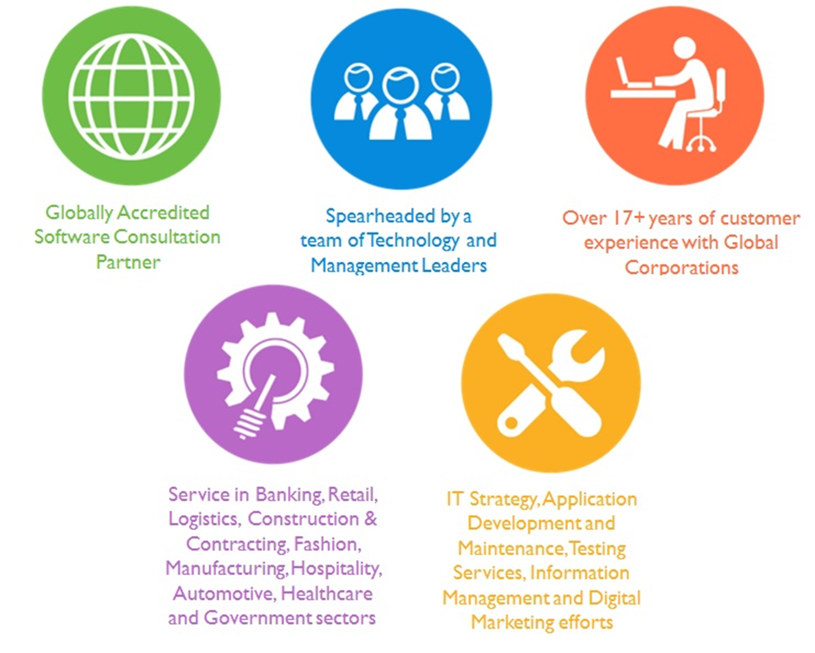

## Key Differentiators

Delivered digital transformation expertise to global customers for over a decade by following industry best practices to maximize ROI for client

Keen technology intelligence combined with aggressive market research to deliver solutions that achieve results with measurable value

Enable access to global consulting expertise with strong local market and business knowledge

Commercial Model that is customizable for your business needs

Services that are designed to optimize applications for improved performance and overall efficiency

1,000,000 plus man-hours of expertise in technology frameworks spanning Microsoft, Open Source, mobility platforms and other proprietary IT technology

Partners top technology vendors to bring in the latest and best services in integration, collaboration, and development

Commercial Model that is customizable for your business needs

Proven Methodologies & Processes

Investment in R & D

Strong Local Presence

Flexible commercial Models

Technology Associations

Software Development Experience

Offshore Development Centre

Quality Assurance & Testing

## Technology & Services



Technology  
&  
Services

Cloud/Traditional Hosting

User Interface & Design

Digital Marketing

Mobility Solutions

Testing Services

Application  
Development

# Functional Specification

|  |
| --- |
| **Admin** |
| Assign roles |
| Manage Users |
| Manage Fees |
| Manage inspection check list |
| Manage Fines |
| Configure scheduler, gateways etc. |
| Upload documents as proxy |
| **General Pages** |
| Privacy Policy |
| Announcements |
| About |
| Help |
| **New Permit** |
| Submit Documents |
| Documents Review |
| Vehicle inspection results validation |
| Pay fees and fines |
| Print Permits and sticker |
| **Permit Renewal** |
| Workflow adjustment for renewal |
| **Re print Sticker** |
| Submit request with required documents |
| Review Documents |
| Review Fines and complaints |
| Approve or reject |
| Pay fees and fines |
| disable previous permit no |
| Notify results |
| Issue new sticker |
| **Cancel Permit** |
| Verify and review current permit |
| Review pending fees or fines |
| Pay fines |
| approve / reject request |
| Notify permit holder |
| **Inspection and Fines** |
| Assign Inspector , inspection date and time |
| Retrieve inspection list for vehicle and vehicle history |
| Record inspection results |
| Add inspection evidence via photos |
| Determine fines based on inspection results |
| print fines per vehicle |
| Send SMS and emails to permit holder |
| **Mobile App development (Android)** |
| **Android API Development** |
| **Reports (3 reports)** |
| Report template customizations for printing |
| **Third party API Integration (SMS, Muroor, Tahseel)** |
| **General application features** |
| search |
| dashboard for applicants, Permit holder, TSD Staff, TSD Manager & inspector |
| application tracking |
| Complaints management |
| **System features** |
| Authentication & authorization |
| Auditing & logging |
| Exception handling |
| Scheduled jobs |
| On Screen guides |
| Workflow management |
| Localization (English & Arabic) |
| Document Archival |

# Functional Architecture

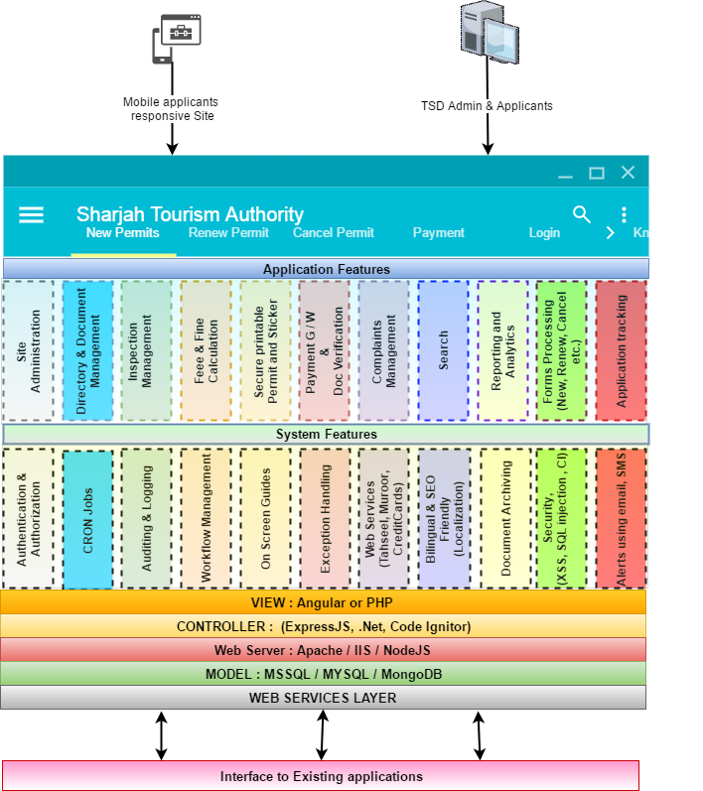

Figure Functional Architecture

The proposed application is an MVC based application that is technology agnostic. In the section titled “High Level Architecture”, verbat has proposed a reference implementation using the Open Source Technologies (more details covered in that section), but this is by no means is a limitation on the proposed technical architecture. The same can be achieved using a .Net or PHP based implementation. The functional architecture depicted above broadly classifies the features of the proposed implementation into “Application” and “System” level features.

System level features are what Verbat considers as non functional requirements while the application level features are functional requirements that were stipulated by the client. Below you will find a run down of the various features that the proposed application will have.

## Application Level features

* Site Administration: An enterprise site administrator will manage various aspects of the site. Site administration consists of activities such as (but not limited to)
  + Adding new users, assigning roles
  + Adding new types of fees and fines for various vehicle violations and permits
  + Configuring gateways
  + Adding new items to the inspection checklist
  + Uploading documents
  + Mining logs to identify system issues
* Directory and Document Management: The application tracks and manages the documents uploaded by the users. Documents are filed into directories (conceptually) that are uniquely identifiable and assigned to the user. Directories may also contain other attachments such as the results of the inspection logs
* Inspection management: This modules keeps a track of all the vehicles that needs to be inspected. The inspector shall be provided with an inspection check list based on the make and model of the vehicle. The inspector shall record the results of the inspection. The results may be accompanied by video, audio or images. These images may be attached to the inspection log
* Fee and Fine Management: Based on the length of time the permit is requested, fees are calculated. Fees and fines are also assessed based on complaints received as well as any violations registered against the applicant or vehicle (by the inspector)
* Printable Permits and Stickers: Barcoded permits and stickers may be printed by the user as soon as they are issued. System will generate bar codes based on some predefined rules
* Payment gateway and Document Verification: The system allows users to make payments of fees or fines using integrated payment gateways or using Tahseel. On the same note all documents that are uploaded by the applicant can be verified by comparing the information on the documents with Muroor. Both of the above activities will be done in real time by integrating with external systems by leveraging their web services.
* Complaints management: Complaints may be registered on the site by the general public as well as by operators or applicants. This will require a system to manage disputes. Complaints may be categorized and tiered based on urgency and priority. They may then be routed or escalated to the appropriate TSD personal
* Search: An integrated search can be used within various modules to look up applicants, vehicles, complaints etc.
* Dashboard with Reporting: Custom dashboards shall be provided to the various stakeholders of the system. Depending up on their entitlements various reports and analytics will be available.
* Forms processing: The system has various forms (new applicant, reorder prints, cancel permits etc.). These forms have various pieces of functionality/information that are common. Common data management and retrieval techniques will enable the application to be more scalable and adaptable
* Application tracking: Any time during the application process, users will be able to track the progress of their application. TSD managers will be able to query the status of the vehicle inspections near to real time.

## System Level Features

* Authentication and Authorization: The system will validate the identity of the user and then authorize the user and assign a specific role that they have been mapped to by the admin
* Auditing and Logging: The system will log the activity of the logged in user so that it can be tracked for security purposes. The system will also log the actions being performed by the system so that it can identify issues caused by systemic application failures
* Scheduled Jobs: The system will have scheduled jobs running at specific intervals. The scheduled jobs makes it possible to identify permit holders with expiring licenses. These jobs can also be used to automatically disable access for expired licenses as well as send out notifications and alerts to permit holders and TSD staff. Another use would be to archive old documents
* Workflow Management: The application maintains different queue for different roles. When an applicant has fulfilled his application requirements, the system will move the application to the concerned TSD staff. The system will also be smart enough to (Re) assign the application to the TSD manager or inspector based on the action taken by the TSD staff. Workflow will keep track of the different states that the application has gone through so that it can easily be queried by the concerned user
* On Screen Guides: On screen guides provide context sensitive guidance based on the role of the logged in user. Textual hints will also be interspersed across different elements on the site
* Exception Handling: As a part of managing user expectations, exceptions or inadvertent application failures will be handled by providing user friendly and contextual error messages. All exceptions will be logged for future reference so that it can be handled better.
* Web Service integrations: Web service framework to integrate various third party integrations such as credit cards, Muroor, Tahseel etc. will allow for the application to freely exchange information.
* Localization & SEO Friendliness: Localization will allow for the application to be multilingual, so that it can display different currencies, languages and direction of the flow of text.
* Document Archival: An application that must handle a large amount of documents for its various users, must find a way to archive documents that are no longer used or documents that belong to expired accounts. Archival provides a means by which these documents can be securely stored on a resource dedicated for it. Verbat will provide the mechanism for archival, but the client will have to provide hardware or software necessary to fulfil this requirement
* Security: Security of the site is managed through a combination of the logs maintained by the system as well as additional functions such as
  + Secure communication using SSL
  + Password salting
  + Provision to secure the site against Cross Site Scripting attacks (and reflected XSS), SQL Injection attacks, Code Injection , buffer overflow vulnerability
* Messaging: A messaging framework to support communication via email and SMS messages for the various function points in the system.

# High Level Solution

## High Level Architecture

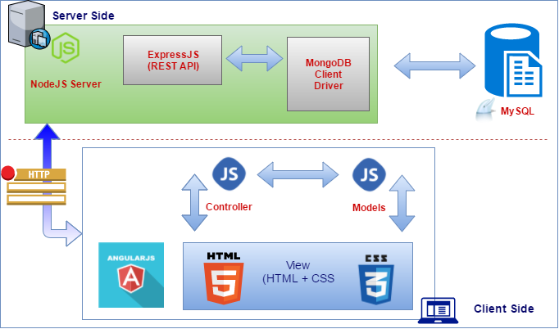

Figure High Level Technical Architecture

The proposed architecture uses a JavaScript based web application stack popularly known as the MEAN (Mongo DB, Express, Angular & NodeJS) stack.

Angular is a Single-Page Application (SPA), a Web app that loads a single HTML page and dynamically updates that page as the user interacts with the app. SPAs use AJAX and HTML5 to create fluid and responsive Web apps, without constant page reloads. This is particularly useful, since one of the requirements for the application is a state-full page that supports persistence.

MySQL is a relational open source database.

In the MEAN stack NodeJS is JavaScript based server. Node.js is a fast and scalable network application. Node.js uses an event-driven, non-blocking I/O model that makes it lightweight and efficient, perfect for data-intensive real-time applications that run across distributed devices.

Express.js is a Node.js web application server framework, designed for building single-page, multi-page, and hybrid web applications. It is the de facto standard server framework for node.js. Express enables you to easily create web applications by providing a slightly simpler interface for creating your request endpoints.

## Overall System Workflow (High Level)

Figure 3 Overall Workflow

## System Workflow (High Level)

Figure 4 System Workflow

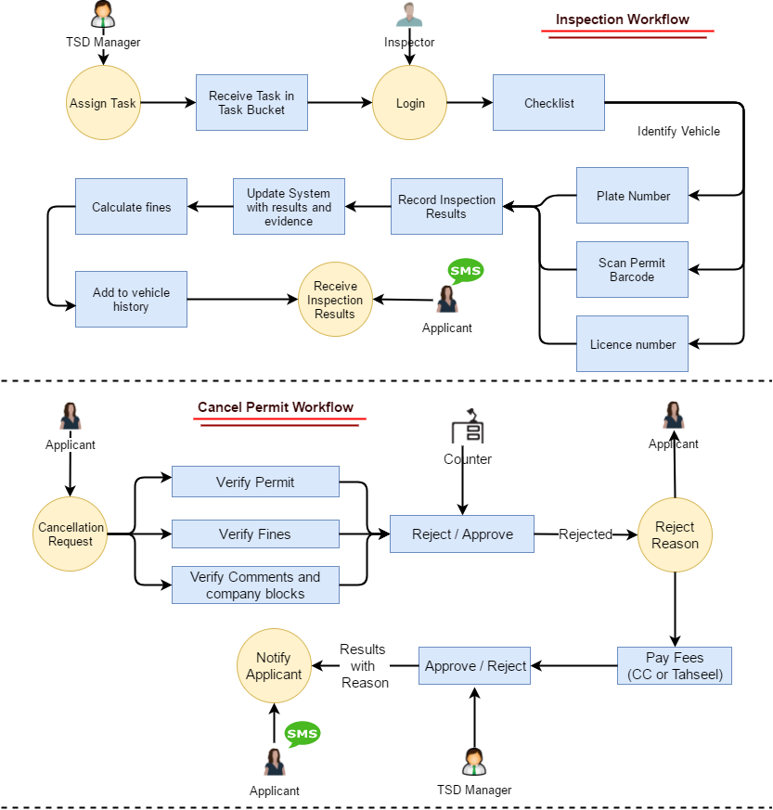

Figure Other Workflows

# Nonfunctional Requirement (Others)

|  |  |
| --- | --- |
| **Requirement** | **Details** |
| User Experience and  UI Design | * The application will be developed only in English and Arabic * The layout and graphical components will be created considering the usability factors |
| Performance | * Application will allow users to have smooth and quick access to the information or services they require. |
| Security | * The system will be protected against attempts of security breaching that may arise. * Web security standards will be followed. |

# Assumptions

The project solution and technology is created from the initial understanding of the requirement shared with Verbat through mails and meetings. The proposed solution is based on the following assumptions:

* Client to provide Verbat with the branding guidelines.
* The proposed application front end and backend would be in English
* Client will purchase the necessary templates needed for development
* Client shall provide licensed images and logos in specified size & format
* Super Admin can manage all the users within the application.
* Requirements should be well defined, agreed and signed-off by the client
* Internet connectivity is required for the functioning of the web application.
* Assuming open source technology (MEAN, HTML5 & CSS3)
* Customer will procure templates, SSL certificates & Payment processor
* UI development effort is 2-4 hrs. per screen
* Reporting and analytics may require external tools. Current assumption is that analytics will be minimal and simple.
* Testing will be done in latest versions of Google Chrome, Mozilla Firefox & IE web browsers only
* Development Contingent upon timely feedback from client
* Print formats for stickers and permits will be provided by the client and printing will be done on blank paper sheets (Not printed paper)

# Out of Scope

With the ever evolving digital market, the requirement needs should be clear to both the parties involved, hence the importance of mentioning the out of scope details of the project. Following are considered to be out of scope while creating this proposal.

* Purchase of images, fonts
* Adding new features to the application other than mentioned in the functional specification.
* Any language other than English
* Manual data entry
* Hardware Integrations / procurement and purchase
* Database migration
* Content writing
* Content or image procurement or uploading or editing.
* Hosting Infrastructure and Maintenance
* Annual Maintenance of the application (Bug fixing, debugging) - For AMC details, please refer section titled “Maintenance and Support”
* Physical deployment at client’s site
* Backup solution and Disaster recovery

# Technology Solution

## Proposed System Environment



ExpressJS   
NodeJS  
MySQL

Angular

HTML / CSS3

**MS SQL2012  
Windows 8/10  
Web Services**

## Technical Configurations

### Development Tools

* Eclipse
* MySQL
* HTML / CSS 3
* Ajax, JavaScript, JQuery

### Recommended Web Hosting Package

* Medium CPU power – single to dual CPU
* Single Domain
* Windows Sever 2012R2 Data Center
* Disk Space: 5 GB
* Monthly Bandwidth: 10 GB
* Web site Server Software – IIS 8.0

### Browser Compatibility

* Chrome version: 56
* Firefox version: 51
* Edge version: 39

### Hardware Interface

**Desktop**

The application is reliant on hardware interfaces to provide a seamless automated user experience.

* Computer with Windows 8 or 10 OS
* Compatible Browsers as specified in section 7.2.3

# Commercials

## Web Application

|  |  |  |
| --- | --- | --- |
| **No** | **Description** | **Amount (USD)** |
| 01. |  | 00,000.00 |
| 02. |  | 00,000.00 |
|  |  |  |

*Note:*

* *The above cost does not include Application hosting, integration, Project Management or deployment*
* *For change management cost, please refer to section 10 titled Change Management*

## Payment Terms

* Payment terms
* Payment terms
* Payment terms

*Note: Payment should be made within 7 days from the date of the invoice*

## Mode of Payment

By Cheque / DD to Verbanet Technologies LLC

OR

Wire transfer to our bank account

Bank Name : Emirates NBD

Account Name : Verbanet Technologies LLC

Account Number : 1011492858201

IBAN Number : AE61 0260 0010 1149 2858 201

Swift Code : EBILAEAD

Bank Address : Mamzar Branch, Dubai

*Note: Bank charges incurred during wire transfer to be borne by the client. Any local taxes applicable to be borne by the client*

# Delivery Management

## Project Management

The Verbat development center strictly follows industry standards on quality. The project management is process governed by the Verbat Quality Management system and is put to verification through internal audit programs that happen from time to time.

Verbat will dedicate a project manager for the proposed implementation. Verbat proposes Client to identify one project manager who will be driving activities to be undertaken by Client to be the single point of contact for Verbat.

## Roles and Responsibilities

Verbat will assign a dedicated Project Manager/Project Lead to lead the project, who will be the first point contact for Client. He/she will be responsible for planning and managing the various activities within the project. He/she will work closely with Client Project Manager, to give periodic status updates and ensure high level of visibility and comfort on the progress of the project.

The Project Manager/Project Lead will lead the co-ordination between Verbat and Client, thus enabling smooth transitioning of Client requirements to the Verbat’s offshore delivery team, and provide visibility as well as comfort on the progress of the services to Client.

He/she will have periodic meetings with Verbat’s Senior Management, thus ensuring Verbat’s Management commitment and focus on Client initiatives.

## Delivery Activity Summary

|  |  |
| --- | --- |
| Activities | Description |
| Detailed requirement Analysis | Verbat team to conduct detailed study of requirement for the phase. If clarification is required, team will reach out to Client for more information and/or time for discussions. |
| DB Design | DB design for central and test DB. |
| Software Requirement Specification document (SRS) | Once the requirement analysis is completed, Verbat team will submit the SRS document for approval |
| UI/UX Design, Prototyping | Based on the SRS, Verbat UX/UI team will work on the UI/UX of the screens and submit a prototype for approval |
| Functional Specification Document (FS) | Once the Prototype. UI/UX is approved, Verbat shall submit an FS document for approval. |
| Development | Actual system development starts based on the FS. This involves detailed design and software development of Web Application. |
| Testing | Test Planning, test plan creations, internal, integration testing and user acceptance testing. |
| Deployment | Deploying the latest built in the Verbat Test Server. |

## Project Implementation Plan

Verbat will be providing the solution in a stand-alone fixed bid approach which ensures minimum viable solution for quick wins with core focus on the long-term business objective and outcome. Once the implementation is over, Verbat will initiate the application maintenance process (once the maintenance contract is signed) which continues to extend after the implementation.

## Deliverables

* Scope Document
* Project Plan
* Presentation for SCTDA Management
* Functional Specification Document
* System Analysis & User Specification Document
* Design Specification Document
* Prototype of the application
* Test Plan Document
* User Manual
* Source Code
* Fully Developed & Tested Application

## Estimated Delivery Time

The effort estimated for delivering the application as specified in section 2 will be as below:

|  |  |  |  |
| --- | --- | --- | --- |
| **Resource/Skill** | **Month 1** | **Month 2** | **Month 3** |
| **Project Manager** | 48 | 40 | 32 |
| **Business Analyst** | 80 | 8 | 8 |
| **User Experience** | 64 | 16 | 16 |
| **Application Architect** | 24 | 8 | 8 |
| **Lead Developer** | 80 | 160 | 80 |
| **Developer** | 80 | 160 | 120 |
| **Database Architect** | 24 | 8 | 8 |
| **Android Developer** | 40 | 160 | 120 |
| **QA** | 40 | 40 | 240 |
| **Tech Writer** |  |  | 24 |
| **Total Effort** | **217 Man Days** |  | **1736 Man Hours** |

**Verbat Team: Please cross verify the effort with the spread sheet. The effort above is inflated.**

Other Cost

Training?

Hosting?

**UAE working days for prototype from the date of Approval of the project (LPO/Signed proposal) with advance payment: 15 working man days**

**UAE Working days for the development of the application from the Date of Approval of the Prototype: 3 working man months**

| **Activity** | **Deliverables** | **Timeline** |
| --- | --- | --- |
| Project Initiation | Scope Document, Project plan, Presentation to SCTDA Management | 2 days |
| Requirement Specification & System Design | System Analysis & User Specification, Updated project plan, Design Specification document, prototype | 15 days |
| Prototype  (parallel stream ) | Working prototype | Month 1 |
| Development | Test Plan Document | Month 1 - 3 |
| Testing | User Manuals | Month 2 - 3 |
| Deployment | Tested Web, Tablet & Mobile  Application in Android, Source Code | Month 3 |

## Deployment Details (at Clients Behest)

* Client can opt for hosting the application at Verbat’s Server.
* If deployment is at the client’s server, responsibility of deploying the application onto the production environment after conducting the necessary acceptance testing will lie with the client unless and until Verbat’s support is contracted for deployment.

***Note****: Hosting the application at Verbat’s server will call in for additional charges.*

## Release Planning

* Client will be informed about the release date and time through email.
* Client performs the UAT

## Risk and Contingency Planning

Verbat has identified various risk factors associated with this assignment and understands the impact of these risk factors on the project schedules. The objective of this section is to highlight for both Verbat and client, the risk factors, to analyze the impact of the risks on project execution, and to propose strategies to control and reduce the impact of the risk factor.

These various risks, which could arise during the project, are tabulated below along with mitigation implementation.

| Type of risk | Impact | Risk Mitigation | Risk Handling |
| --- | --- | --- | --- |
| Scope Creep | H | Functions and features will be detailed in system requirement documents and will go through client approval. Once this document is approved, any change to requirement will go through change management review for possible impact assessment. | Proper change management procedure will be implemented. |
| Delay in customer feedback | H | The plan is prepared with enough lead-time for customer reviews and approvals.  The customer is indicated with the dates when the document is expected after review and approval. | The request for feedback will be escalated if not attended at the right time so that the schedules are not affected. Deemed acceptance criterion is set up front and will be followed. |
| Non-availability of necessary software’s, frameworks, database instances and infrastructure at client’s hosting environment(If hosting support is provided by Verbat) | M | Client will be informed in advance on these requirements. | Possible impact to schedule. |
| Manpower attrition | L | All efforts would be made to ensure process dependence rather than being person dependent. As a risk mitigation plan Verbat will train backups. | A new person will be identified as early as possible, provided the required project-specific training and mentored by the senior members of the team to minimise impact of attrition on the project. |

*H-High, M-Medium, L-Low, NA-Not Applicable*

# Change Management

Any addition which comes out of the project scope, upon and after the launch of the tool will be considered as change management. Verbat recommends the following change management procedure for the same.

* Any change which comes out of the project scope, which was discussed, documented, and mutually approved by both the parties in the requirement stage, will be carried out only through raising a change request.
* Change request will be studied and an impact analysis on the existing work flow will be performed.
* On finalizing the impact, effort estimation for the change will be calculated and raised as additional requirement.
* Verbat will initiate the change request only after getting a formal approval from the client for the additional changes raised.
* Any change from the scope will be charged at **USD ----- per man day effort** and approval from the clients will be availed before commencing on any change management.

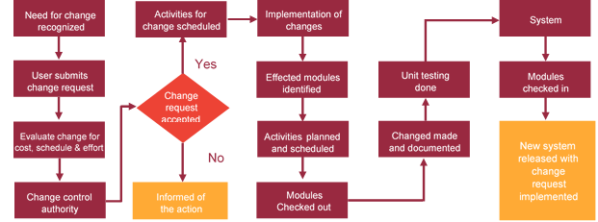

# Miscellaneous

## Acceptance Criteria

* UAT sign off should happen within 7 Days from the release of the application/ Phase and the acceptance confirmation needs to be mailed to Verbat failing which Verbat will consider the project as approved by the client.
* Any comments or reason for rejection need to be documented and the same needs to be sent as an email from the official mail id of client to Verbat.

## General Terms and Conditions

* An average of 20 working days are assumed in a month
* All the projects activities will be carried out from our off-shore development center in India
* The scope of the project is to develop the Application as detailed in the scope of the project and mentioned in this proposal. Any changes or additions will have to go through change management.
* This proposal and all technical/ functional specifications have been derived or concluded from the data shared via email / information's transferred during the initial requirement analysis meetings and conversations. Verbat reserves the right to amend the terms of this proposal, should the SOW terms, functional features and functionalities change during the course of the project
* Application will be best viewed only in the environment mentioned in the section 7.2.3
* All the documentation will be provided in English.
* Third party components may be used to develop this application.
* All Source Code and other project artefacts would adhere to the Verbat document templates and internal coding standards
* Acceptance criteria shall be based on the clauses which were mutually discussed between Verbat and client at the Requirement Analysis phase and the same will be documented and approved by both parties through official emails
* In case Client requires any extension of the proposed acceptance schedule, the associated effort and cost of such extension can be mutually reviewed.
* For any circumstances if project needs to be put on Hold / Stop it requires minimum request notice period of 1 week along with duration for which request will be addressed by management and final decision on the request will be based on that
* If deployment is done in client’s server, Verbat cannot be held responsible for any performance issues arising due to hardware malfunctions.
* Client is responsible for data backup in case the application is not hosted on Verbat server.
* Source code will only be delivered or uploaded on the Production Server once the due payments are made.

## Assumptions and Dependencies

* Detailed system study is required before the start of the project.
* During the requirement gathering phase, authorized personnel from the Client’s side is expected to be available for discussion and finalizing the HLD (High Level Design), before development commences.
* Type of reports and formats, if under the scope of the project, needs to be specified by Client before project sign off.
* Workflows if under the scope of the project, need to be specified/ confirmed by client before project signoff.
* All queries regarding the client requirement and any queries which may hinder the project advancement at any stage should be answered by the client within 24 hours from the time of initiation, failing which the time delay will get added to the actual effort which was estimated.
* Verbat assumes that all sign-offs from Client will be provided within agreed and specified timeframe.
* Client will provide all the necessary contents, both text and image, before starting the project in the format suggested by Verbat (if any).
* The client should provide the relevant information and data well in time for the execution of a related activity. Non- availability of this information or data may lead to an interruption of work which may result in a delay in delivery as well as additional costs to the client.
* Client should have/possess server with technical specifications as suggested by Verbat for the proposed application.

## Source Code & Intellectual Property Rights

* Upon completion of the Project and 100% completion of the payment, client will have access to the source code except for propriety codes, developer tools and third party application etc.
* The solution offered will be the intellectual property of the client and will be made available to the client on an “unlimited license” basis.
* Modifications by third party/person: No person or organization, other than Verbat or any person authorized by Verbat in writing, has any permission to modify/change the software Solution to be eligible to get continued support from Verbat as per the support terms defined under this document.
* Liabilities/Damages: Verbat accepts no liability or damages of any kind arising out of use or non-use of the software delivered. The responsibility of testing of software lies with Client.

## Maintenance & Support

* Maintenance contracts by default are supported as per the basic SLA terms.
* **AMC with Basic SLA is charged at 20 % of the total project value**. Additional Effort/change management request will be added towards Total Value of the Project to determine the AMC value.
* Maintenance support is limited to providing application support for ensuring the consistency of the look-and-feel, bug fixes and user issues i.e. maintenance and support of the existing features of the application.
* Support does not in any way cover providing technical or other support to the end users. The maintenance agreement does not include functionality changes or feature additions which are handled as change requests which will be charged AED 1200 per man day. AMC does not include server support, maintenance and application deployment.
* AMC charges will cover Off-Site Support and Debugging. Support includes E-mail, Telephone and Chat unless explicitly specified. In the event, the application is hosted with the client; necessary remote desktop connectivity should be provided for carrying out maintenance activity.
* Gap in AMC - In case if the client does not opt an AMC for a year and want to renew it after that period, 50% of the AMC amount for the year for which AMC is not taken will also be payable if the client wishes to renew the AMC contract.
* Note:
  + Please note that the AMC support shall start only after all the necessary sign-offs (AMC Document) to this effect have been given.
  + It is not mandatory that the client should opt for an AMC. The client will still be supported on an ad-hoc basis on an agreed man-day rate.
  + AMC Payment Terms: 100% to be paid as advance.

## Service Level Agreement

|  |  |  |  |  |
| --- | --- | --- | --- | --- |
| **Key** | **Max Response Time** | | **Max Resolution Time** | **Target** |
| Basic | 1  working day | 3 working days | | Request / incident / problem tickets |
| Advanced | 5 Business Hours | 12 Business Hours | | Request / incident / problem tickets |
| Priority | 3 Business Hours | 5 Business Hours | | Request / incident / problem tickets |

Note:-

* We provide Basic SLA as standard with AMC while Advanced and Priority SLAs attract additional charges.
* Time zone applicable as per India time zones (3:30 AM GMT to 12:30 PM GMT- Monday to Friday).

# Our Clients

**UAE University**

Education

Transportation

**Canada Cartage**

Construction

Services

Finance

We look forward to hearing from you soon and hope that you will give us the privilege to work with you in meeting your business goals. Thank you.

Thank You



©   
1999 - 2017. All Rights Reserved   
Verbanet Technologies LLC  
www.verbat.com